Python Assignment 2: Data Structures - List, Dictionary, Set & Conditional Statements

List (Creation, Modification and Access):
List Creation:
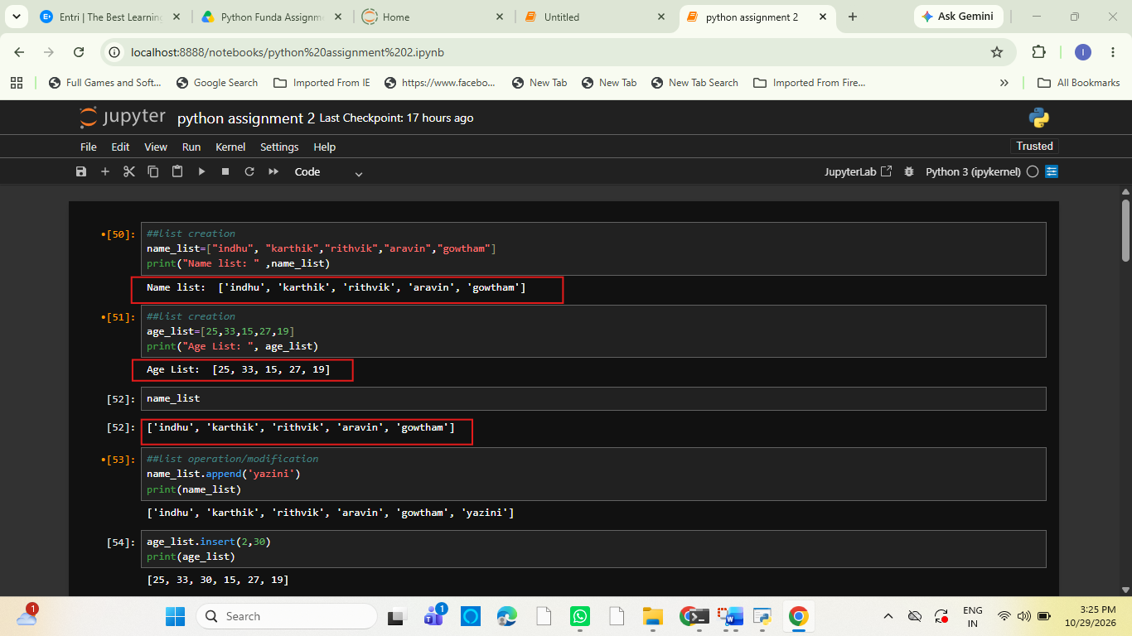

2. List Operations / Modifications:
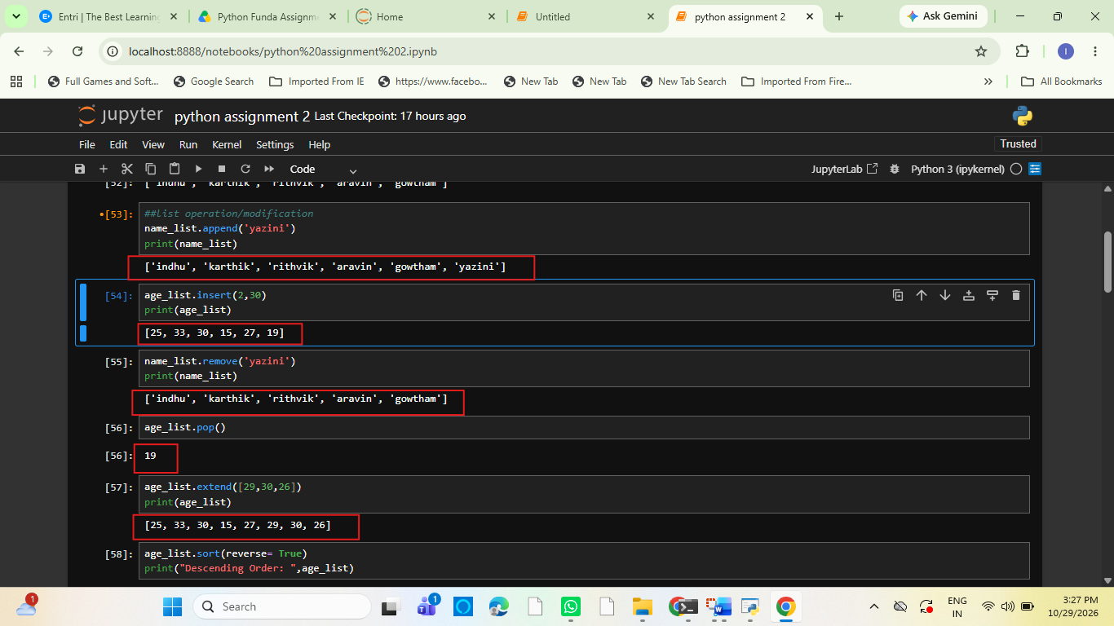
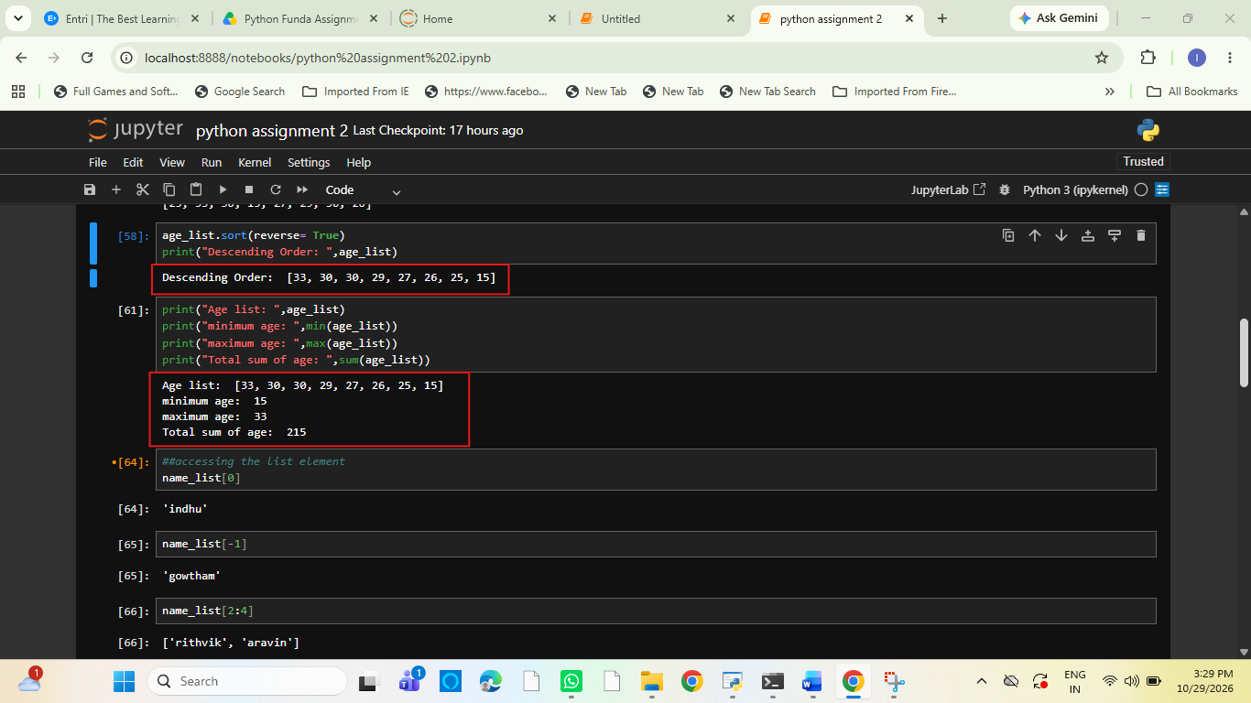
3. Accessing List Elements:
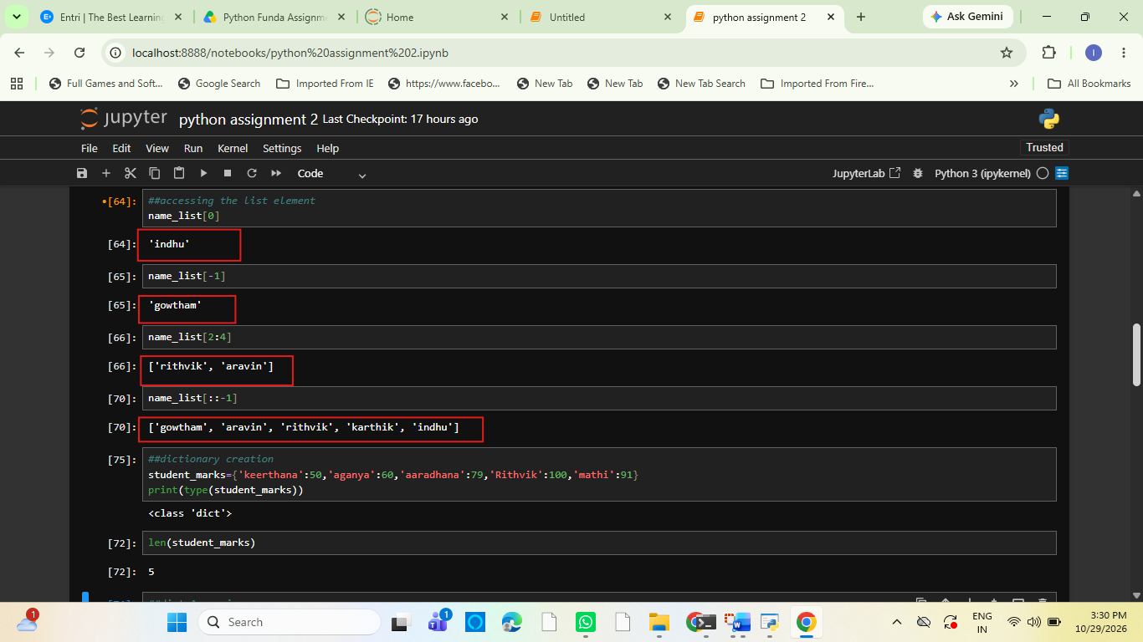

Dictionary (Creation, Modification and Access):
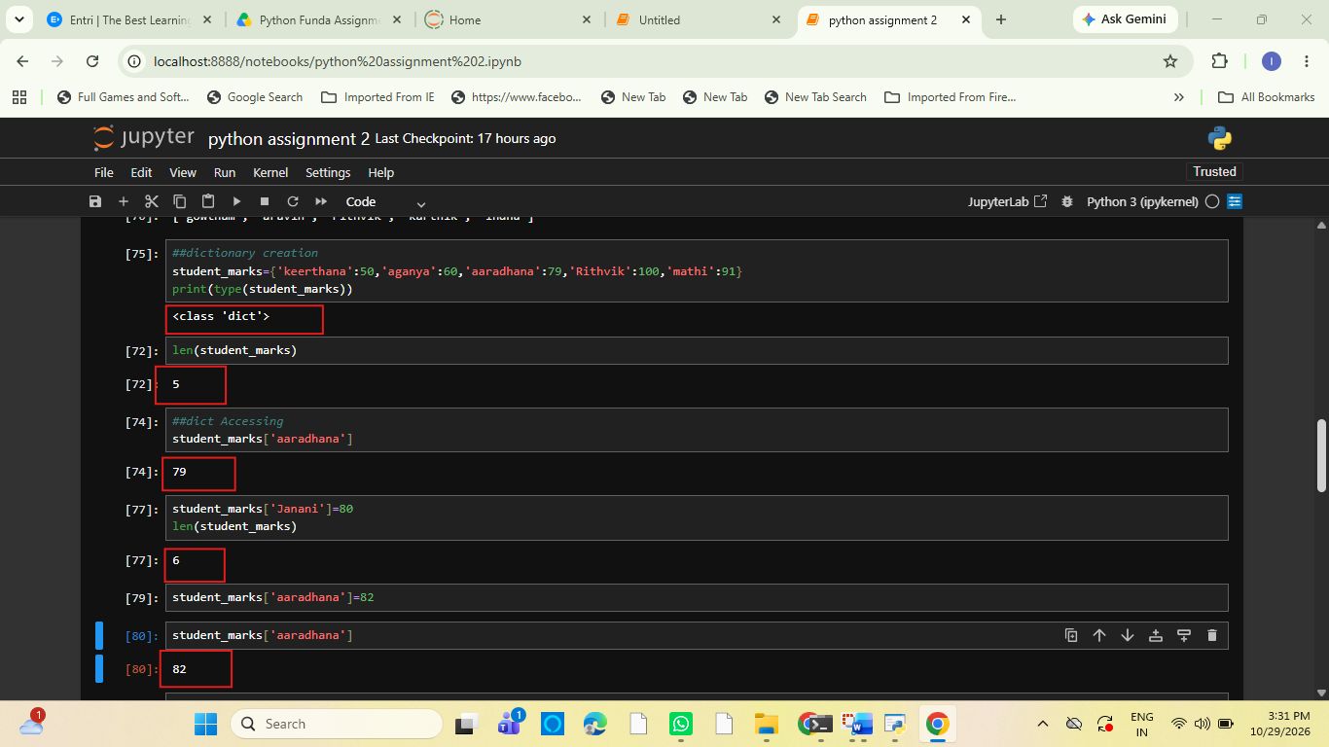
Sets (Operations):
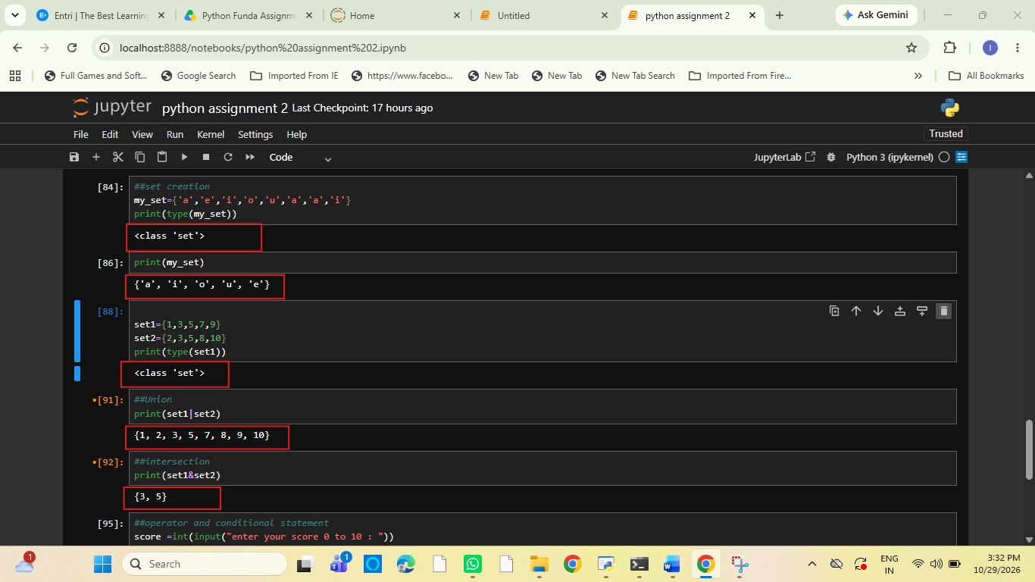
- Set is unordered, unique value
- It remove duplicates

Operators & Conditional Statements :
(IF, ELIF, ELSE)
